A WEB-BASED TRACER AND EMPLOYMENT ANALYTICS SYSTEM FOR THE ALUMNI RELATIONS AND LINKAGES OFFICE
A Capstone Project Manuscript
Presented to the Institute of Computer Applications
Central Mindanao University
By
WASHELEY TAN
ELVIN LAR GONZALES
Bachelor of Science in Information Technology
APRIL 2026

SIGNED APPROVAL SHEET
This capstone project manuscript entitled "A Web-Based Tracer and Employment Analytics System for the Alumni Relations and Linkages Office" has been prepared and submitted by Washeley Tan and Elvin Lar Gonzales in partial fulfillment of the requirements for the degree Bachelor of Science in Information Technology. This page is reserved for the signatures of the adviser, panel members, and approving officials.

_______________________________
Adviser
_______________________________
Panel Member
_______________________________
Panel Member
_______________________________
Panel Member
_______________________________
Institute Director

AUTHOR'S BIOGRAPHICAL SKETCH
Washeley Tan and Elvin Lar Gonzales are Bachelor of Science in Information Technology students of Central Mindanao University. Their capstone work focuses on the development and documentation of a web-based tracer and employment analytics system intended to support alumni record management, graduate tracking, job linkage, communication, and administrative reporting for the Alumni Relations and Linkages Office. Through this project, the authors applied systems analysis, database design, web application development, software testing, and technical documentation practices required in information technology project work.

ACKNOWLEDGMENT
The researchers express their sincere gratitude to Central Mindanao University, the Institute of Computer Applications, the project adviser, panel members, instructors, classmates, family members, and the Alumni Relations and Linkages Office for the guidance, support, and encouragement given throughout the development of this capstone project. Their assistance helped the researchers understand the importance of accurate alumni records, responsible data handling, and useful employment analytics for institutional planning and graduate engagement.

_______________________________
WASHELEY TAN
_______________________________
ELVIN LAR GONZALES

EXECUTIVE SUMMARY
The study entitled "A Web-Based Tracer and Employment Analytics System for the Alumni Relations and Linkages Office" presents the design and documentation of a centralized web application for alumni profile management, tracer record submission, job posting, job application handling, announcements, feedback, notifications, audit logging, and employment analytics. The system responds to the need for organized alumni records and timely reports that can assist the Alumni Relations and Linkages Office in monitoring graduate outcomes and maintaining communication with alumni.
The project uses Laravel 12, PHP 8.2, PostgreSQL, Blade templates, Tailwind CSS, Vite, Chart.js, and supporting notification services. Its design follows a relational database model centered on users, tracer records, jobs, applications, job submissions, announcements, feedback, notifications, sessions, and audit logs. The project documentation includes a Data Flow Diagram Level 0, Entity Relationship Diagram, Use Case Diagram, testing summary, and recommendations for further improvement.
The results of the documentation review show that the proposed system is capable of supporting the major requirements of an alumni tracer and employment analytics platform. The recommendations focus on completing deployment planning, strengthening data privacy controls, improving reporting features, adding more user evaluation, and maintaining the system through regular testing and documentation updates.

COPYRIGHT PAGE
Copyright 2026 by Washeley Tan and Elvin Lar Gonzales. All rights reserved. No part of this manuscript may be reproduced, stored, or transmitted in any form without proper acknowledgment of the authors and the institution, except for academic review, evaluation, and archival purposes allowed by the Institute of Computer Applications.

TABLE OF CONTENTS
CHAPTER I INTRODUCTION 12
1.1 Background of the Study 12
1.2 Statement of the Problem 12
1.3 Objectives of the Study 13
1.4 Scope and Limitations of the Study 13
1.5 Significance of the Study 14
CHAPTER II REVIEW OF RELATED LITERATURE/SYSTEMS 15
2.1 Graduate Tracer Studies and Alumni Information 15
2.2 Web-Based Alumni Systems 15
2.3 Security, Privacy, and Data Protection 15
2.4 Technology Support for Analytics 16
2.5 Summary of Review 16
CHAPTER III TECHNICAL BACKGROUND 17
3.1 Laravel and PHP 17
3.2 PostgreSQL Database 17
3.3 Blade Templates, Tailwind CSS, and Vite 17
3.4 Chart.js Analytics 17
3.5 Notification and Integration Support 18
CHAPTER IV METHODOLOGY 19
4.1 Software Development Methodology 19
4.2 Requirements Analysis 19
4.3 Requirements Documentation 19
4.4 Design of Software, System, Products, and Processes 19
4.4.1 Data Flow Diagram Level 0 20
4.4.2 Entity Relationship Diagram 20
4.4.3 Use Case Diagram 22
4.5 Development and Testing 23
4.6 Description of the Prototype 23
4.7 Implementation Plan (Infrastructure and Deployment) 23
4.8 Implementing Rules 24
4.9 Maintenance 24
CHAPTER V RESULTS, DISCUSSION, AND CONCLUSION 25
5.1 Results 25
5.2 Discussion 25
5.3 Conclusion 25
CHAPTER VI RECOMMENDATION 27
CHAPTER VII REFERENCES 28
Appendix A. Project Repository and Supporting Materials 29

LIST OF TABLES
Table 1. Summary of Reviewed Literature, Systems, and Technical References 16
Table 2. Testing Summary of the Proposed System 23

LIST OF FIGURES
Figure 1. Data Flow Diagram Level 0 of the Proposed Web-Based Tracer and Employment Analytics System 20
Figure 2. Entity Relationship Diagram of the Proposed Web-Based Tracer and Employment Analytics System 21
Figure 3. Use Case Diagram of the Proposed Web-Based Tracer and Employment Analytics System 22

LIST OF APPENDICES
Appendix A. Project Repository and Supporting Materials

CHAPTER I
INTRODUCTION

1.1 Background of the Study
Alumni information is an important institutional resource because it provides evidence of graduate employability, supports curriculum improvement, and strengthens long-term engagement between a university and its graduates. When alumni information is collected manually or stored in separate files, the office responsible for alumni relations may experience delays in updating records, preparing reports, and communicating opportunities to graduates.
The proposed A Web-Based Tracer and Employment Analytics System for the Alumni Relations and Linkages Office addresses these concerns by providing a centralized platform where alumni can register, maintain their profiles, submit tracer information, view announcements, browse employment opportunities, apply for jobs, and send feedback. Administrators can manage records, job postings, announcements, job submissions, feedback, audit logs, and analytics from a controlled dashboard.
Graduate tracer data is especially useful because it helps institutions understand employment status, industry placement, job satisfaction, salary range, and the relevance of academic preparation to actual work. The system therefore combines record management with analytics so that collected data can be transformed into reports that support planning and decision-making.

1.2 Statement of the Problem
This study is guided by the general problem of how to design and document a web-based tracer and employment analytics system that improves the efficiency, accuracy, and usefulness of alumni records management for the Alumni Relations and Linkages Office.
Specifically, the study seeks to answer the following questions:
- How can alumni registration, profile maintenance, and tracer data submission be centralized in a single web-based platform?
- How can the system support job posting, job application, feedback submission, announcements, and alumni engagement activities?
- How can administrators manage records, submissions, announcements, feedback, audit logs, and reports through role-based access?
- How can the system generate useful employment and tracer analytics for planning and decision-making?
- How can the database and process design maintain data consistency, privacy, traceability, and accountability?

1.3 Objectives of the Study
The general objective of the study is to develop and document a web-based tracer and employment analytics system for the Alumni Relations and Linkages Office.
Specifically, the study aims to:
- Provide a secure registration, authentication, and account recovery mechanism for alumni and administrators.
- Allow alumni to maintain personal, academic, employment, scholarship, and tracer-related information.
- Provide modules for jobs, job submissions, job applications, announcements, notifications, and feedback.
- Enable administrators to manage alumni records, submissions, announcements, jobs, feedback, audit logs, and reports.
- Produce analytical outputs that summarize tracer and employment information for institutional use.
- Design a database structure and process flow that support consistent and auditable information management.

1.4 Scope and Limitations of the Study
The scope of the study covers the design and documentation of the CMU ARLO platform for two major user roles: alumni and administrator. Its functional coverage includes authentication, profile management, tracer submissions, job postings, job applications, alumni-submitted job opportunities, announcements, notifications, feedback management, audit logs, and analytics dashboards.
The study is limited to a web-based implementation and the database structures reflected in the current project repository. It does not include full enterprise integration with payroll systems, third-party human resource platforms, or automated government reporting systems. Final production deployment details and maintenance procedures are intentionally left blank in this manuscript version, as requested.

1.5 Significance of the Study
The study is significant to the Alumni Relations and Linkages Office because it provides a more organized way to collect, update, monitor, and analyze alumni information. For university administrators, the system can support evidence-based decisions about graduate employability and alumni engagement. For alumni, it provides a convenient channel for maintaining records, receiving announcements, submitting tracer information, and accessing job opportunities. For future researchers, the project may serve as a reference for similar systems that combine alumni tracing, employment analytics, and web-based information management.

CHAPTER II
REVIEW OF RELATED LITERATURE/SYSTEMS

2.1 Graduate Tracer Studies and Alumni Information
Graduate tracer studies are used to determine the employment status, career movement, competencies, and educational experiences of graduates after leaving an institution. The Commission on Higher Education has used graduate tracer study instruments to collect information about employability and the relevance of higher education programs. These practices support the need for structured data collection and careful reporting in alumni-related systems.
Nabablit and Dajao (2023) presented a web-based graduate tracer information system with data analytics, showing that tracer data can be managed through an online platform and used to generate reports for decision-making. This related work supports the direction of the proposed system because the CMU ARLO project also combines alumni information management with employment analytics.

2.2 Web-Based Alumni Systems
Web-based alumni systems commonly include registration, profile management, announcements, job opportunities, and communication features. These modules reduce dependence on manual files and make it easier for alumni to update their own records. In the proposed system, these ideas are reflected in the alumni dashboard, tracer workflow, job board, job submission workflow, announcements, notifications, and feedback module.

2.3 Security, Privacy, and Data Protection
Because alumni systems process personal, academic, and employment information, privacy and security are important design concerns. The Philippine Data Privacy Act of 2012 emphasizes lawful, fair, and purpose-based handling of personal information. The OWASP Application Security Verification Standard also provides guidance for verifying web application security controls. These references support the use of authentication, role-based access, audit logs, validation, account controls, and careful handling of sensitive records in the proposed system.

2.4 Technology Support for Analytics
The project uses Laravel for server-side web application structure, PostgreSQL for relational data storage, and Chart.js for visual analytics. This combination supports controlled data processing, structured queries, and dashboard-based visualization of tracer and employment information. The literature and technical references show that a web-based platform can improve accessibility while analytics can turn collected records into more useful institutional outputs.
Table 1. Summary of Reviewed Literature, Systems, and Technical References
Reference/System | Key Feature | Contribution to the Proposed System
CHED Graduate Tracer Study | Graduate profile and employability data collection | Supports the tracer information structure of the proposed system
Nabablit and Dajao (2023) | Web-based graduate tracer information system with analytics | Supports the combination of alumni records and reporting features
Data Privacy Act of 2012 | Lawful and purpose-based handling of personal information | Guides privacy, consent, and controlled access considerations
OWASP ASVS | Security verification requirements for web applications | Supports authentication, validation, and security testing concerns
Laravel, PostgreSQL, and Chart.js documentation | Framework, database, and charting references | Guides the technical background and implementation tools

2.5 Summary of Review
The reviewed literature and technical references establish the importance of centralized alumni records, tracer data collection, privacy-aware processing, secure access, and dashboard-based reporting. These findings support the proposed system's design as a web-based tool for alumni management and employment analytics.

CHAPTER III
TECHNICAL BACKGROUND
This chapter describes the main technologies and technical concepts used in the proposed system. The project is implemented as a Laravel-based web application that uses a relational database, server-side validation, Blade views, front-end styling tools, and charting libraries for analytics presentation.

3.1 Laravel and PHP
Laravel 12 serves as the main application framework, while PHP 8.2 provides the server-side programming language. Laravel organizes routing, controllers, form requests, middleware, authentication, notifications, services, models, database migrations, and tests. These framework features support maintainable development and consistent handling of alumni and administrator workflows.

3.2 PostgreSQL Database
PostgreSQL is used as the relational database management system. It stores users, tracer records, jobs, applications, job submissions, announcements, announcement reads, feedback, notifications, sessions, and system logs. The database design uses primary keys, foreign keys, status fields, timestamps, and indexes to support data integrity and reporting performance.

3.3 Blade Templates, Tailwind CSS, and Vite
Blade templates provide the server-rendered views of the application. Tailwind CSS supports user interface styling, while Vite handles asset bundling and development builds. These tools help create separate but consistent interfaces for alumni and administrator users.

3.4 Chart.js Analytics
Chart.js is used to display employment trends, graduation distributions, tracer summaries, and dashboard analytics. By converting database records into visual summaries, the system helps administrators interpret collected alumni data more quickly.

3.5 Notification and Integration Support
The system includes notification support for announcements, job submission review outcomes, and user-facing updates. The repository also contains services for Facebook page publishing and synchronization, which may be used to support communication through the official Alumni Relations and Linkages Office page when properly configured.

CHAPTER IV
METHODOLOGY

4.1 Software Development Methodology
This study follows the Waterfall model as the software development methodology. The model was selected because the capstone project requires a clear sequence of requirements analysis, documentation, system design, development, testing, and final reporting. Its structured nature supports the preparation of formal diagrams, database design, and manuscript documentation.

4.2 Requirements Analysis
The requirements analysis phase identified the main needs of the Alumni Relations and Linkages Office. These include alumni account registration, alumni profile management, tracer data submission, job opportunity posting, job applications, announcements, notifications, feedback, audit logs, and analytics. The requirements were grouped according to the two main user roles: alumni and administrator.

4.3 Requirements Documentation
The requirements were documented through narrative descriptions, use case definitions, data flow representation, entity relationship modeling, and functional module descriptions. The use case definitions identify what each actor can do, while the data and process diagrams show how information moves through the system.

4.4 Design of Software, System, Products, and Processes
The system design phase focused on database structure, process flow, user roles, interface modules, and validation rules. The following diagrams were reviewed against the current project repository and adjusted through explanatory notes to ensure that they match the main implemented workflows.

4.4.1 Data Flow Diagram Level 0
The Data Flow Diagram Level 0, also called the context diagram, presents the system as one major process interacting with two external entities: Alumni and Administrator. This level correctly avoids internal data stores and focuses on the major input and output flows between users and the proposed system.
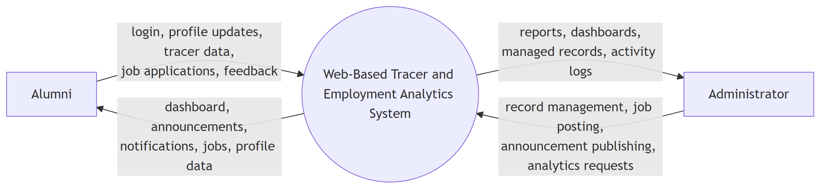
Figure 1. Data Flow Diagram Level 0 of the Proposed Web-Based Tracer and Employment Analytics System
The Level 0 diagram was checked and found consistent with the project scope. Alumni provide credentials, profile updates, tracer data, job applications, and feedback, while the system returns dashboard content, announcements, notifications, job information, and profile data. Administrators provide management and reporting requests, while the system returns reports, dashboards, managed records, and activity logs.

4.4.2 Entity Relationship Diagram
The Entity Relationship Diagram illustrates the database entities and their relationships. The main model centers on the Users entity because alumni and administrators are represented through user accounts. Users are connected to tracer records, job applications, job submissions, jobs, announcements, feedback, notifications, system logs, and sessions.

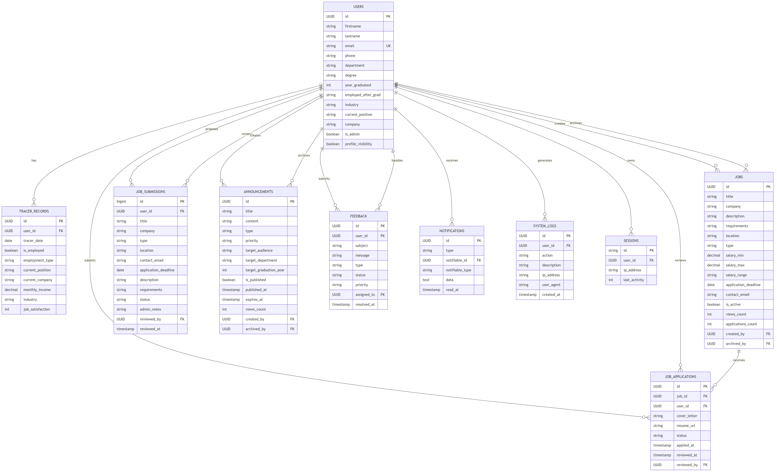
Figure 2. Entity Relationship Diagram of the Proposed Web-Based Tracer and Employment Analytics System

The ERD was reviewed against the Laravel migrations and matches the major conceptual relationships used by the system. For a complete physical database model, the team should also include the announcement read-tracking table and any extended user/tracer fields such as sex, data privacy consent, scholarship data, import metadata, and employment proof metadata. These items are support details that strengthen the physical schema but do not change the main conceptual flow of the ERD.

4.4.3 Use Case Diagram
The Use Case Diagram summarizes the functional requirements of the system by showing the interactions between Alumni, Administrator, and the major system functions. Alumni use account, profile, tracer, job, announcement, notification, and feedback features. Administrators use dashboard, record management, job management, announcement, feedback, analytics, and audit log features.
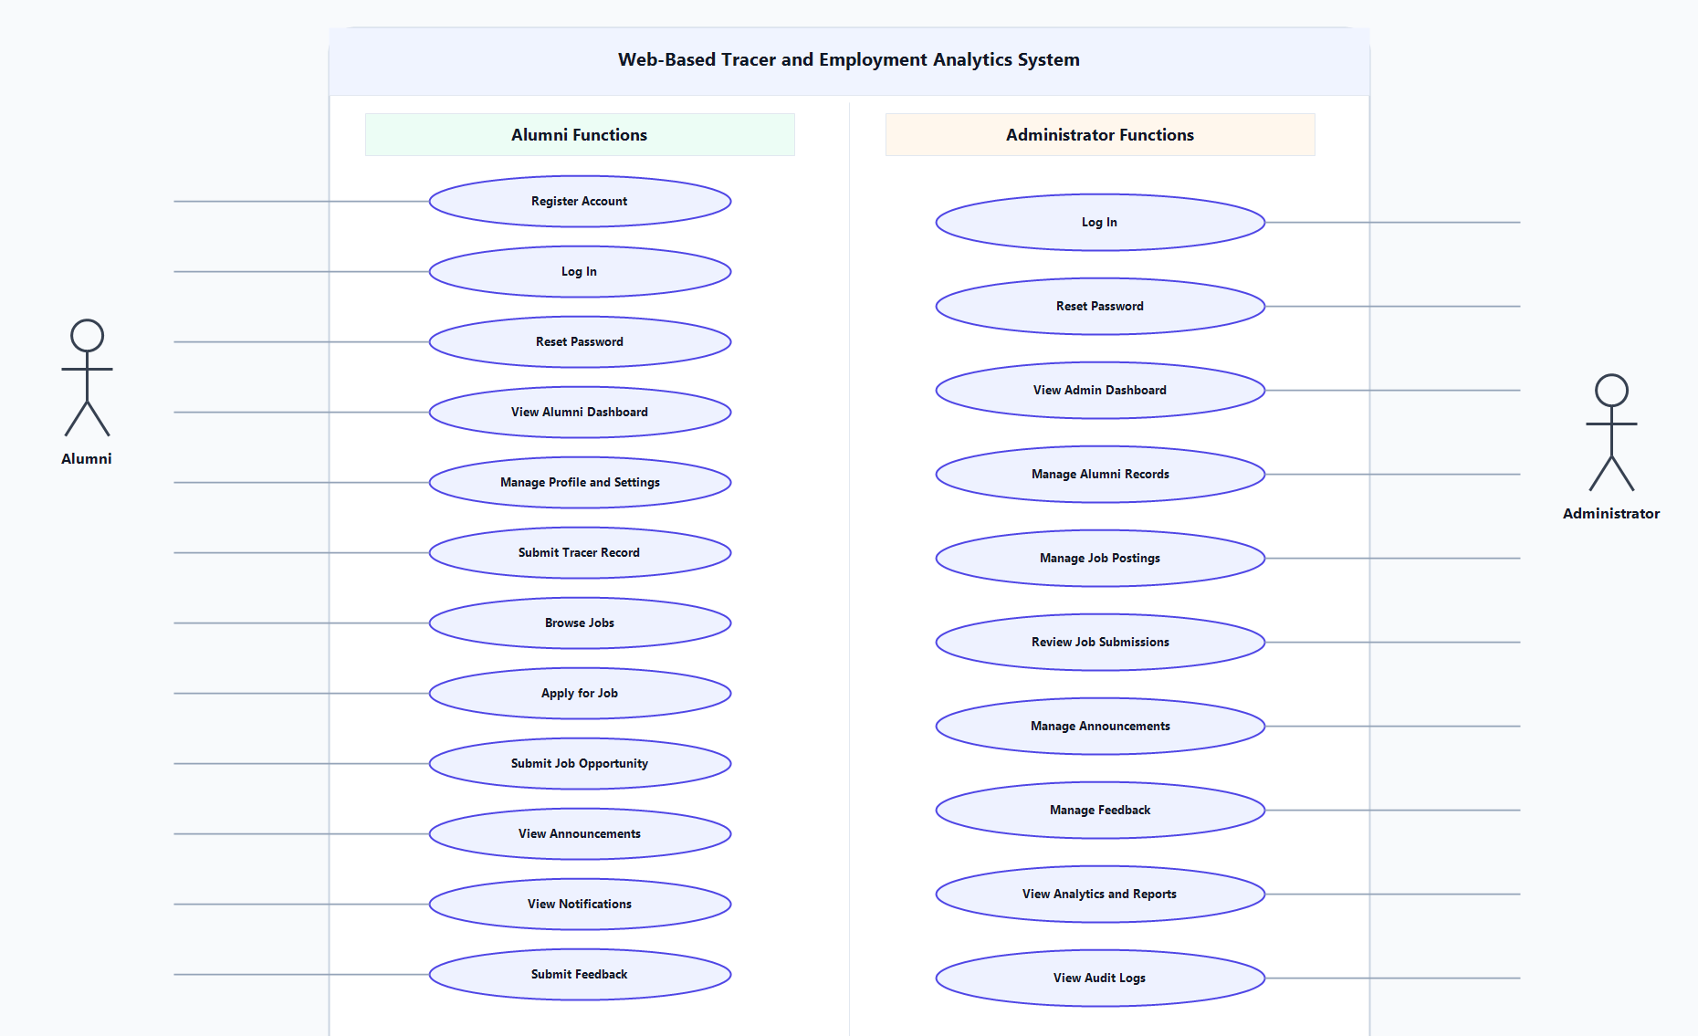
Figure 3. Use Case Diagram of the Proposed Web-Based Tracer and Employment Analytics System
The Use Case Diagram was checked and found aligned with the implemented routes and controllers. The only correction note is that each actor-to-use-case association should appear once in the final source diagram; the Alumni association to Submit Feedback should not be duplicated in the diagram source.

4.5 Development and Testing
The development phase translated the documented requirements and design into Laravel controllers, models, form requests, services, database migrations, Blade views, and supporting JavaScript. Testing focused on authentication, alumni workflows, administrator CRUD operations, audit logs, feedback, job applications, announcement visibility, and account deletion cascade behavior.
Table 2. Testing Summary of the Proposed System
Testing Phase | Scope/Parameters | Key Objective
Feature Testing | Authentication, admin CRUD, feedback, jobs, announcements, account deletion | Verify that critical workflows behave correctly
Exploratory Testing | Manual checking of edge cases and unusual user actions | Identify workflow inconsistencies and validation gaps
User Acceptance Testing | End-to-end alumni and administrator workflows | Confirm that the system supports office requirements
Performance and Data Testing | Simulated records and concurrent user behavior | Check responsiveness of reports, dashboards, and database queries

4.6 Description of the Prototype
The prototype includes separate interfaces for alumni and administrators. Alumni can register, log in, update profiles, submit tracer records, browse jobs, apply for jobs, submit job opportunities, read announcements, view notifications, and submit feedback. Administrators can manage alumni records, create announcements, manage jobs, review job submissions, monitor feedback, view analytics, and review audit logs.

4.7 Implementation Plan (Infrastructure and Deployment)

4.8 Implementing Rules
The system should be used according to role-based access. Alumni accounts should be used only by verified alumni, while administrator accounts should be limited to authorized office staff. Personal and employment data should be collected only for legitimate tracer, reporting, and alumni engagement purposes. Administrators should review submitted job opportunities before publishing them, monitor feedback responsibly, and maintain audit logs for accountability.

4.9 Maintenance

CHAPTER V
RESULTS, DISCUSSION, AND CONCLUSION

5.1 Results
The documented system provides a centralized structure for alumni records, tracer submissions, jobs, announcements, feedback, notifications, and analytics. The database design connects the major entities needed to track users, employment records, job activity, administrative actions, and communication records. The diagrams support the explanation of how users interact with the system and how data flows through the application.
The review of the repository indicates that the project includes implemented modules for alumni and administrator workflows, as well as feature tests for important system behavior. These results show that the project is not limited to design documentation but is supported by working application components and verification activities.

5.2 Discussion
The system addresses the identified problem by reducing scattered record handling and providing a single platform for alumni-related data. The administrator dashboard and analytics features help transform collected records into summaries that can support decision-making. The inclusion of audit logs, validation, account controls, and privacy-related fields also strengthens accountability and responsible handling of alumni data.
The diagram review showed that the DFD Level 0 and Use Case Diagram are aligned with the main project scope. The ERD is conceptually correct for the central data model, but the final physical ERD should be updated whenever new support tables or fields are added to the database migrations.

5.3 Conclusion
Based on the documentation and repository review, the proposed system is suitable as a web-based platform for alumni tracing and employment analytics. It supports the major workflows needed by alumni and administrators, provides a structured relational database, and includes reporting features that can help the Alumni Relations and Linkages Office monitor graduate outcomes. Continued refinement is recommended before final production deployment, especially in the areas of privacy compliance, maintenance planning, user evaluation, and deployment documentation.

CHAPTER VI
RECOMMENDATION
The researchers recommend that the system be completed with a formal deployment and maintenance plan before final production use. This plan should identify the hosting environment, domain configuration, database backup schedule, environment variables, queue worker setup, mail configuration, storage settings, monitoring process, and rollback procedure. Since the deployment and maintenance sections are intentionally left blank in this manuscript version, they should be completed after the team finalizes the target infrastructure.
It is also recommended that the team update the final ERD to include all current physical database details, especially announcement read tracking and extended user and tracer fields. Keeping the ERD synchronized with migrations will make the documentation more accurate and easier to defend during evaluation.
For security and privacy, the system should undergo a focused review based on the Data Privacy Act of 2012 and practical web application security standards. The review should cover data collection notices, consent fields, account verification, password recovery, role-based access, file upload handling, audit logs, session behavior, and database backup protection.
For usability, the researchers recommend conducting additional user acceptance testing with actual Alumni Relations and Linkages Office staff and selected alumni representatives. Their feedback should be used to refine form labels, dashboard summaries, tracer questions, filters, reports, and notification messages.
For future enhancement, the system may include exportable reports, mobile-responsive improvements, alumni verification workflows, stronger notification preferences, advanced filtering for analytics, automatic report generation, and long-term archival tools for inactive records. These enhancements can help the platform remain useful as the alumni database grows.

CHAPTER VII
REFERENCES
Chart.js. (2025). Chart.js documentation. https://www.chartjs.org/docs/latest/
Commission on Higher Education. (2017). CHED Graduate Tracer Study. https://ched.gov.ph/wp-content/uploads/2017/11/CHED-00000016.pdf
Laravel. (2026). Laravel 12.x documentation. https://laravel.com/docs/12.x
Meta. (2026). Graph API documentation. https://developers.facebook.com/docs/graph-api/
Nabablit, K. J. E., & Dajao, E. S. (2023). Development of a Web-Based Graduate Tracer Information System with Data Analytics. In Proceedings of the Eighth International Congress on Information and Communication Technology (pp. 601-611). Springer. https://doi.org/10.1007/978-981-99-3091-3_50
National Privacy Commission. (2012). Republic Act No. 10173: Data Privacy Act of 2012. https://privacy.gov.ph/data-privacy-act/
OWASP Foundation. (2025). Application Security Verification Standard. https://owasp.org/www-project-application-security-verification-standard/
PostgreSQL Global Development Group. (2026). PostgreSQL documentation. https://www.postgresql.org/docs/
Royce, W. W. (1970). Managing the Development of Large Software Systems. Proceedings of IEEE WESCON, 1-9. https://www.praxisframework.org/files/royce1970.pdf

APPENDICES

Appendix A. Project Repository and Supporting Materials
Supplementary materials may include system screenshots, test cases, database migration files, selected source code listings, user acceptance testing forms, and final deployment notes once the deployment and maintenance plan has been completed.

